**Structure of DB – ZerLi**

**item:**

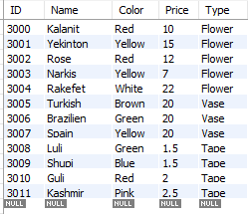

Special attributes:

* ID – PK

**self_item:**

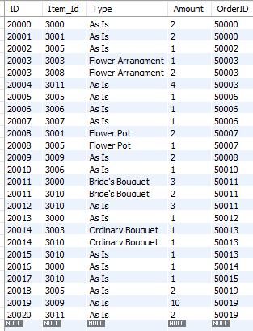

Special attributes:

* ID – PK
* Item_Id – PK , FK (item.ID)
* Type – PK
* OrderID – FK (orders.ID)

**item_in_catalog:**

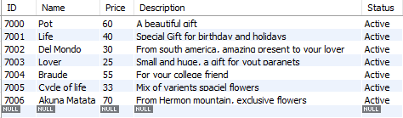

Special attributes:

* ID – PK

**orders:**

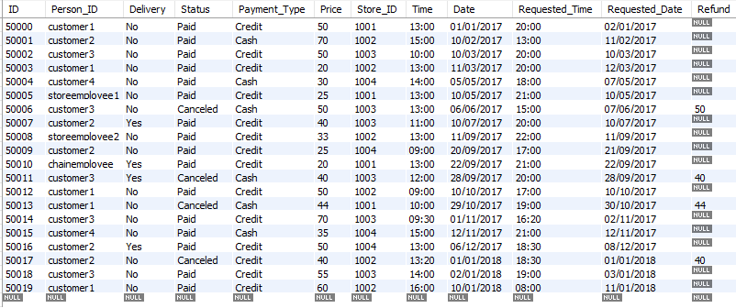

Special attributes:

* ID – PK
* Person_ID – FK (payment_account.ID)
* Store_ID – FK (store.ID)

**item_in_order:**

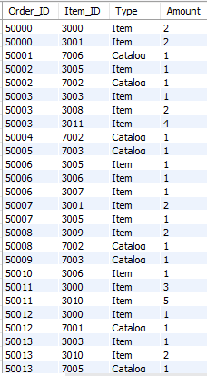

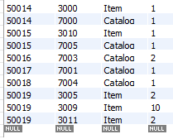

Special attributes:

* Order_ID – PK , FK (orders.ID)
* Item_ID – PK, Not FK!

**person:**

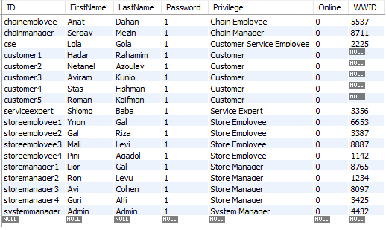

Special attributes:

* ID – PK

**card:**

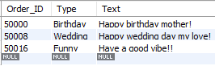

Special attributes:

* Order_ID – PK , FK (orders.ID)

**payment_account:**

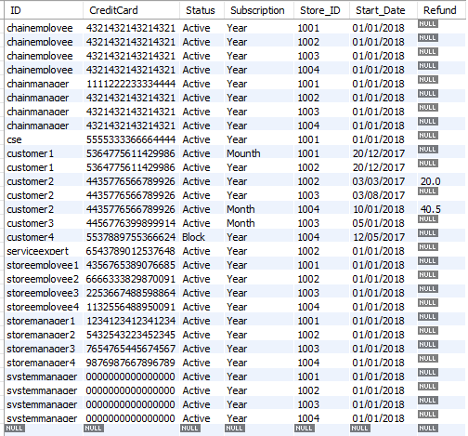

Special attributes:

* ID – PK , FK (person.ID)
* Store_ID – PK, FK(store.ID)

**delivery:**

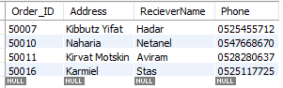

Special attributes:

* Order_ID – PK , FK (order.ID)

**complaint:**

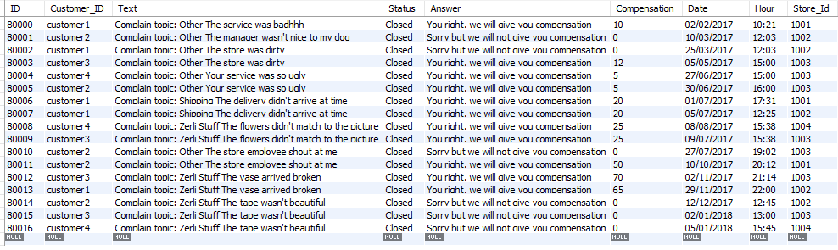

Special attributes:

* ID – PK
* Customer_ID – FK (person_ID)
* Store_Id – FK (store.ID)

**sales:**



Special attributes:

* ID – PK

**store:**

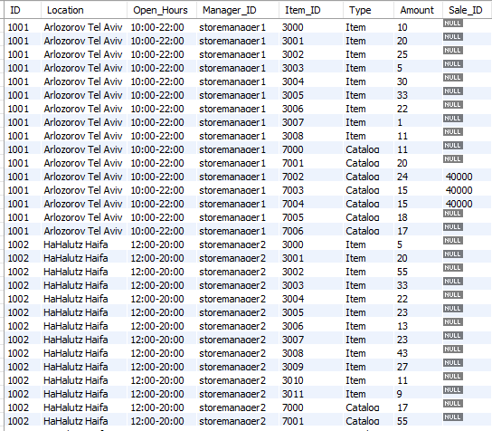

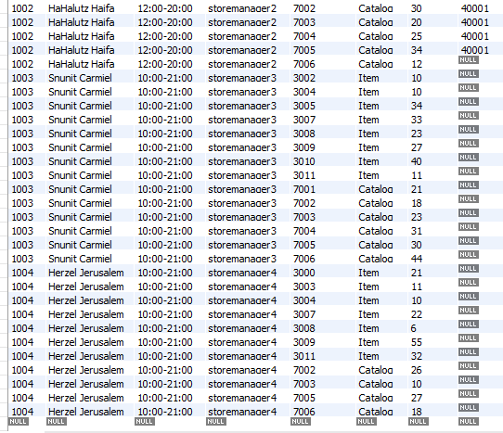

Special attributes:

* ID – PK
* Item_ID - PK
* Manager_ID – FK (person.ID)
* Sale_ID – FK (sales.ID)

**survey:**

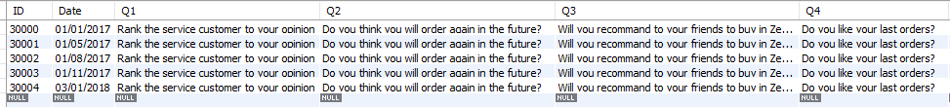

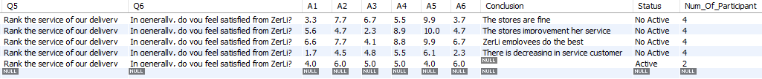

Special attributes:

* ID – PK

**comments_survey:**

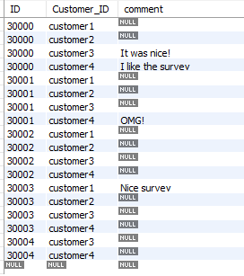

Special attributes:

* ID – PK, FK (survey.ID)
* Customer_ID – PK, FK (person.ID)